|  |  |
| --- | --- |
| **Ex No: 2**  **Date: 14-08-24** | **Multi Class Classification** |

**Objective:**

To build a logistic regression classifier to recognize type of flower using Gradient descent implementation.

**Descriptions:**

Multi Class classification is the task of classifying elements of a given set into distinct groups. We aim to train the logistic regression model such that given a new image xxx, it can predict the class to which the image belongs.

Logistic regression is a supervised learning algorithm that can be extended to handle **multiclass classification problems**, where labels can take one of multiple values, such as 0, 1, 2, ..., C−1C-1C−1, for CCC different classes. An input feature vector XXX may correspond to an image that we want to classify into one of several categories (e.g., cat, dog, bird, etc.). In this case, we want an algorithm that outputs a probability distribution across all classes and assigns the class with the highest probability as the predicted label y^\hat{y}y^​.

Logistic regression for multiclass problems doesn’t have any hidden layers, similar to binary logistic regression. The prediction process uses a **softmax function** to output a probability distribution over all possible classes.

**Model:**

**Building the parts of algorithm**

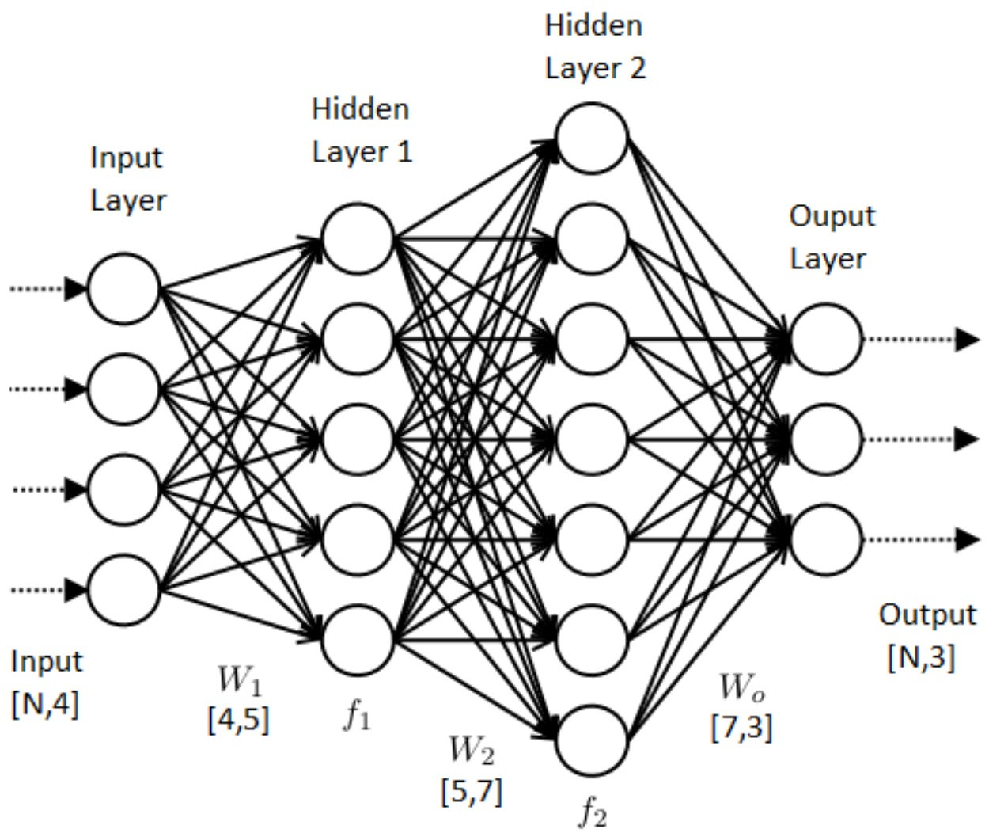

The main steps for building a Neural Network are:

1. Define the model structure (such as number of input features)
2. Initialize the model's parameters
3. Loop:
   * Calculate current loss (forward propagation)
   * Calculate current gradient (backward propagation)
   * Update parameters (gradient descent)

**GitHub Link:**

**https://github.com/is-harshit/Deep-Learning/tree/main/Lab2**